1. Shri. M Manjunath –

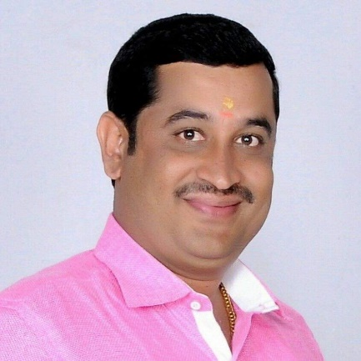

Edu - BA

1. Shri Shivanna N C ,

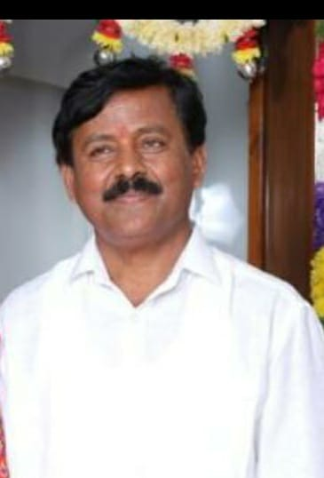

Edu – MA, M.Phil  
 Rtd.Principal

1. Shri.M MohanKumar

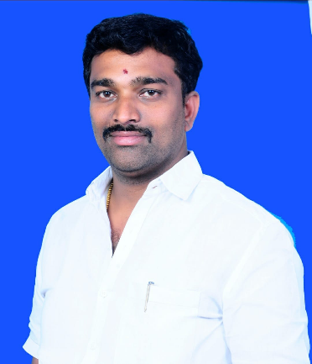

Edu - Dip civil

1. Shri M Thimma Reddy

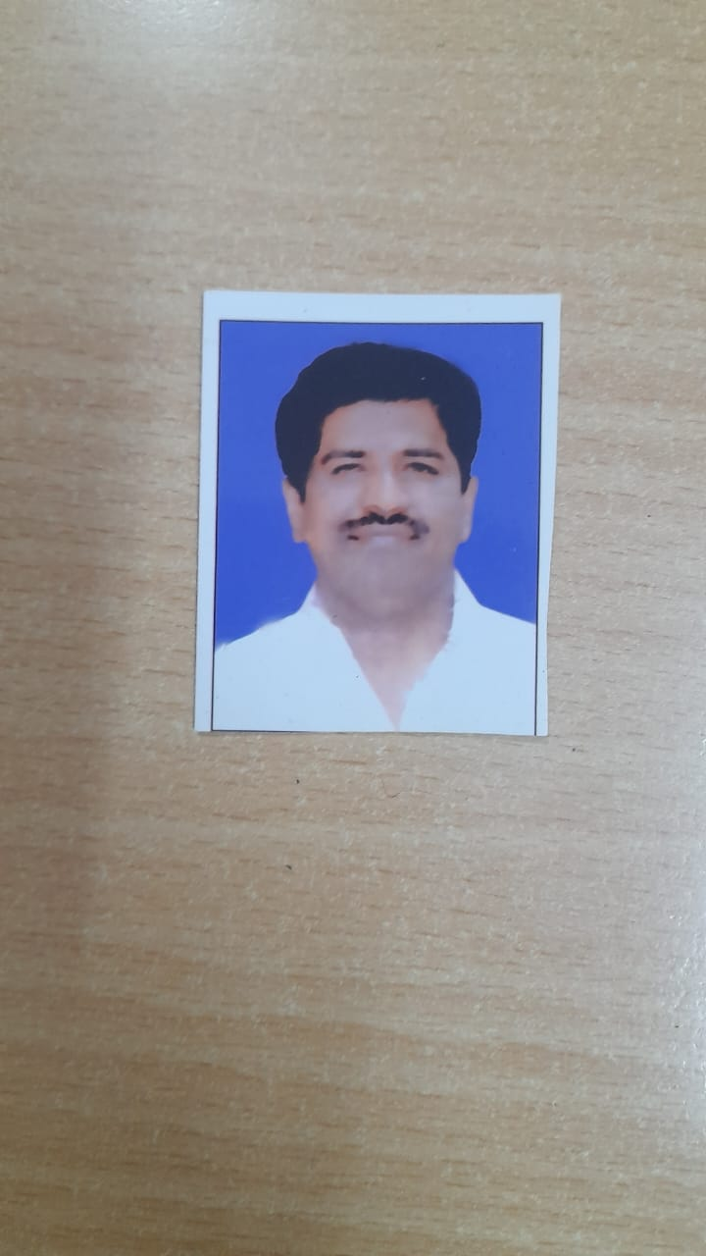

Edu - BSC, B.Ed